Computer Language Coding Concepts

Inactive Clauses in a Command Definition in a Diagram
Inactive clauses in a command definition have been conceptually explained in the article Inactive Clauses in a Command Definition.

This article only illustrates how inactive clauses in a command definition look in a diagram.

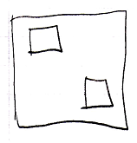

The larger square is a command definition. The smaller squares inside the larger square are inactive clauses inside a command definition. Squares inside a square, that do not redirect are inactive clauses.

See also: Inactive Clauses in a Command Definition,
Creation Behavior of Command Calls in a Diagram

Author & Copyright: Jan-Joost van Zon Date: August 9, 2008 – August 9, 2008 Location: Oosterhout, The Netherlands Status: Finished

